Photograph Locations for Changes to Streambed Rock Size along the Rockfish South Fork.
March 12, 2020 Kate Humphrey Chambers

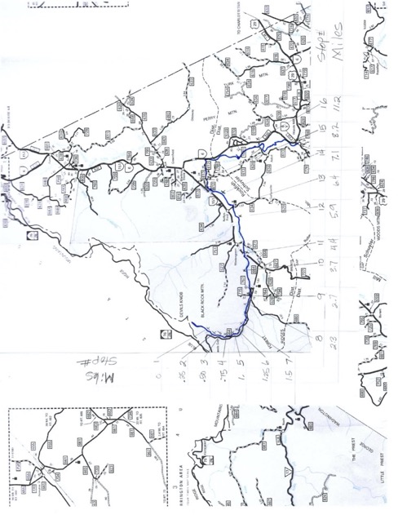

Stop 1, Mile ~0
Very close to the source of the Rockfish South Fork. Note only large boulders.

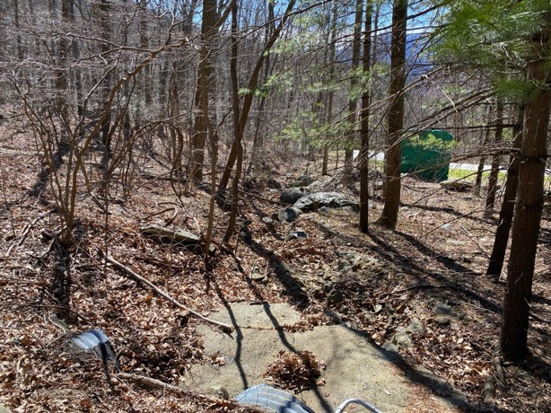

Stop 2, Mile ~0.25
One quarter mile from the headwaters. Note steady stream of river flow. Largest boulders along edge (not middle) of stream and some smaller sizes now in the center of the stream.
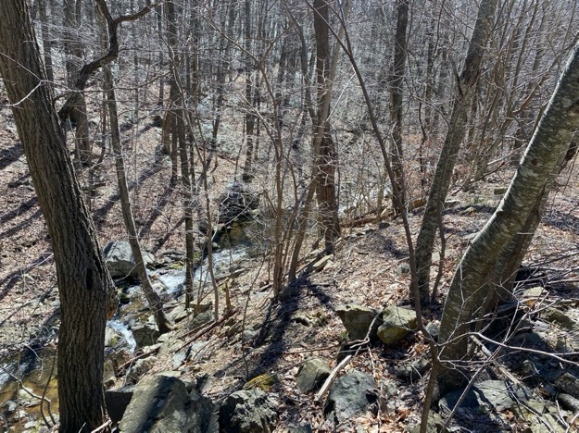

Stop 3, Mile ~0.50
One half mile from the headwaters, and already more distribution of largest boulders away from the stream’s edge. Higher frequency of smaller rocks and evidence of some sand-sized particles.

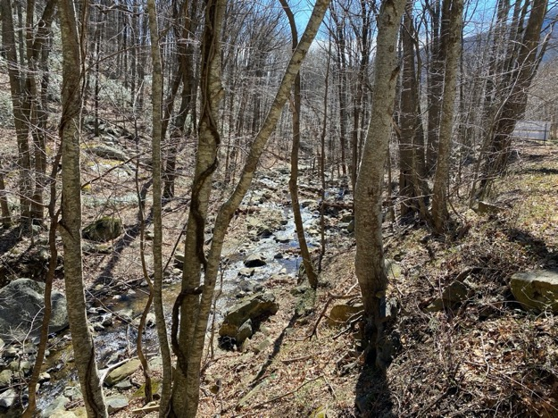

Stop 4, Mile ~0.75
Three-quarters of a mile, from the headwaters. Note some ponding behind rock ‘dams,’ possibly due to debris slides that are now being cut through. Largest boulders are now in the middle and edges of the stream. 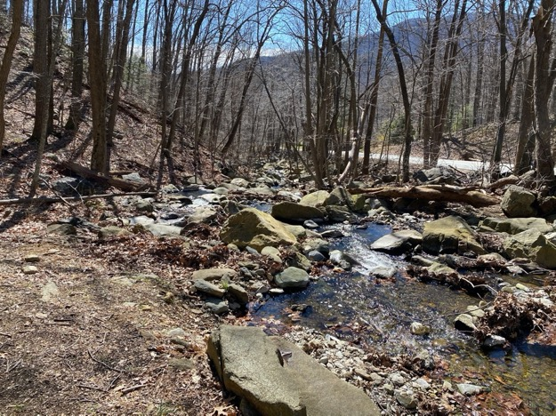

Stop 5, Mile ~1.00
Only one mile from the headwaters, and already a broad range of rock sizes apparent as well as early signs of braided sediment build up with sand-sized grain banks.

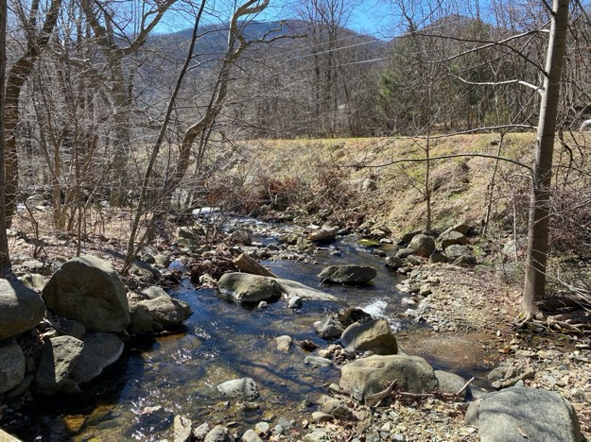

Stop 6, Mile ~1.25
Just over a mile from the headwaters, the stream has gathered more tributaries and has a much wider bed. The predominant rock size is much smaller with occasional large boulders.

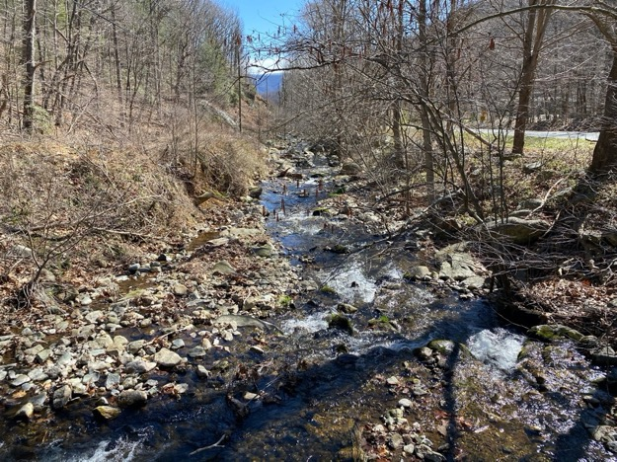

Stop 7, Mile ~1.50
Now 1.5 miles from the headwaters, the stream is inherits a lower grade slope and has the largest rocks largely submerged. Rock size distribution is expected to be wider and with a lower mean.

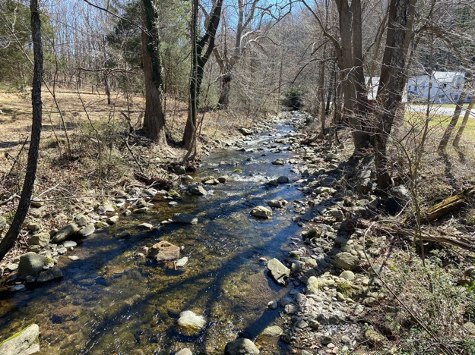

Stop 8, Mile 2.30
Moving downstream now almost another mile, the stream is farther from the steeper hillsides and lower grade. Note numerous smaller rocks, developed banks, rock shapes much more smooth and sometimes flatter. Larger boulders in the middle of the stream are also more rounded, indicating that higher flow levels are eroding the edges. 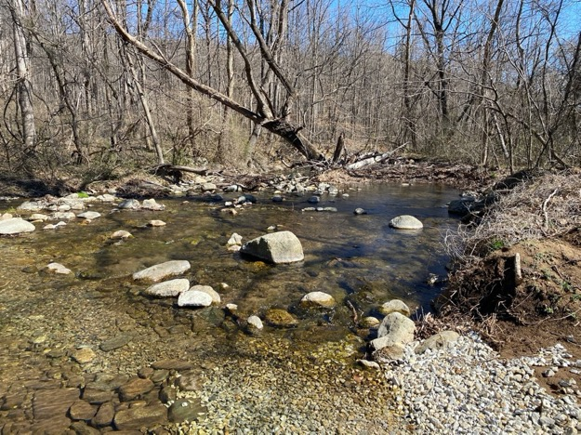

Stop 9, Mile 2.70
Moving downstream another half mile (not very far!) note far fewer large boulders in the stream’s center. Banks are well defined.

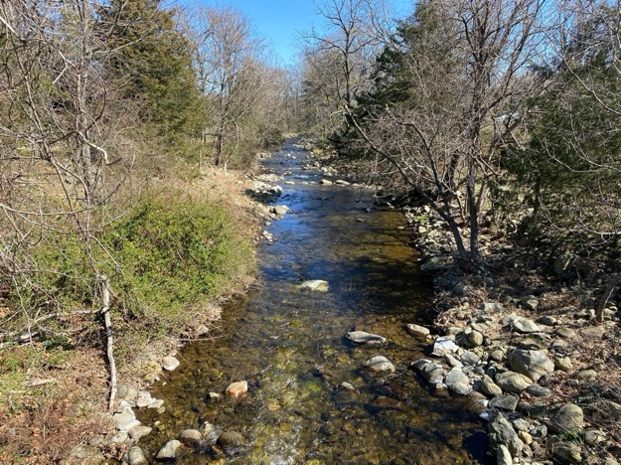

Stop 10, Mile 3.70
Moving downstream a full mile, the stream is starting to meander. Note the deposition of smaller material at a bend.

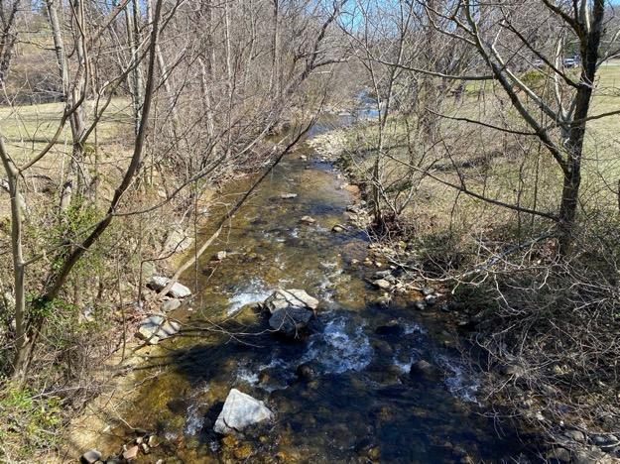

Stop 11, Mile 4. 40
Moving downstream not quite another mile, note much more evidence of meandering streams, overflow banks, and the absence of large boulders at the surface.
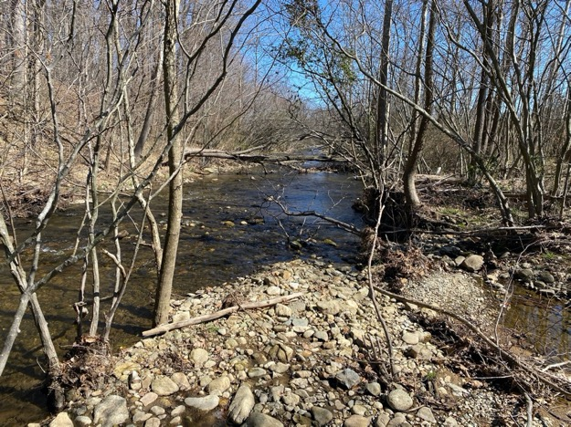

Stop 12, Mile 5.90
Almost six miles now from the headwaters, note the largest rocks are only at the banks. It’s only a guess at the rock size distribution at this point, but the bed appears to show uniform fist-sized rocks with sand grains below.

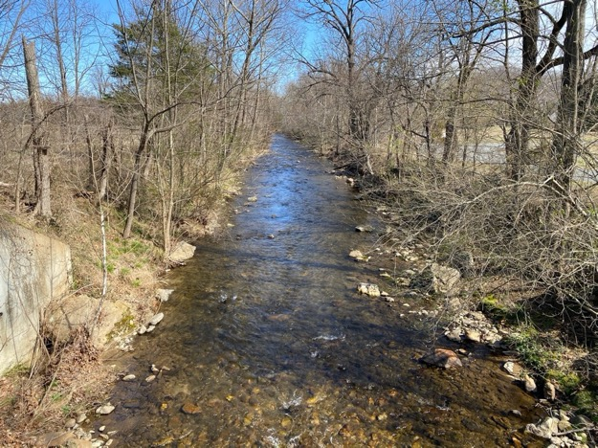

Stop 13, Mile 6.40
In just another half mile, the river comes to the edge of hill and hard rock edge – similar to pediments like Elk Hill house is built (Chuck won’t use the word monadnock but he may choose a different phrase.). Note the shallow rapids downstream and the clear, deep and very low amount of loose particles here. Is the stream capable of flushing this location effectively more often than other?

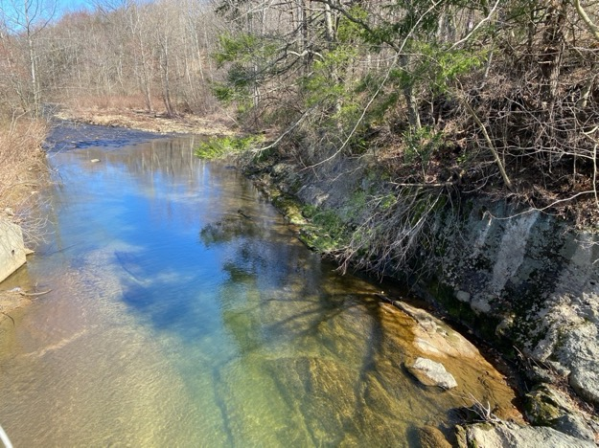

Stop 14, Mile 7.10
In just another half mile – and only ~seven miles from the source, the river has been able to erode rock sizes into a bi-modal distribution – rather small as well as some boulders.

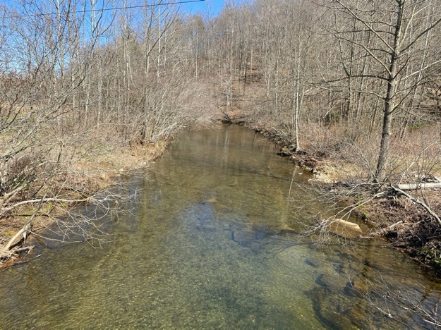

Stop 15, Mile 8.20
Moving downstream another mile, the stream is wider and has been down-cutting, leaving a higher bank. Note very few boulder sized rocks at the surface or bed.

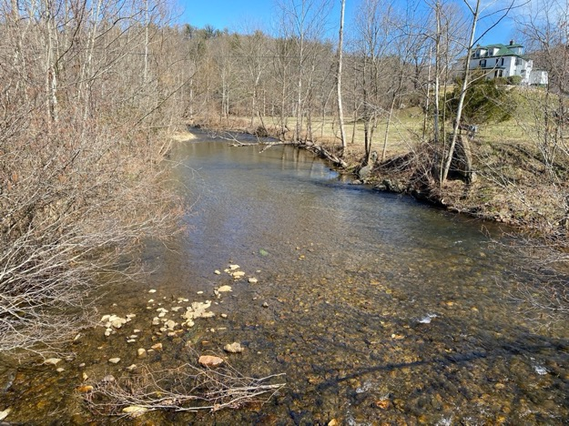

Final stop 16, Mile 11.20
The Rockfish North Fork has now merged with the South Fork. Note high, steep, hard rock cliffs, some banks development with sands.
